**GUJARAT TECHNOLOGICAL UNIVERSITY**

Chandkheda, Ahmedabad

Affiliated



L.J. Institute of Engineering Technology

A Report On:

MANAGIO

Under subject of

DESIGN ENGINEERING – 2A

B. E., Semester – 5

Information Technology

Submitted by

|  |  |  |
| --- | --- | --- |
| Sr. | Name of Student | Enrollment no. |
| 1. | Banker Neel | 161203116001 |
| 2. | Maniyar Preet | 161203116004 |
| 3. | Oriya Himanshu | 161203116007 |
| 4. | Vyas Jaimin | 161203116014 |
|  |  |  |
|  |  |  |
|  |  |  |

Mr.Bhumin Mandaliya Mr.Saurin Dave

Faculty Guide Head of the Department

Academic year (2017-2018)



INDEX

|  |  |  |
| --- | --- | --- |
| No. | Title | Page No. |
| **1.** | **Introduction** | **3** |
| **2.** | **Canvas**  2.1 AEIOU Canvas  2.2 Empathy Canvas  2.3 Ideation Canvas  2.4 Product Developing Canvas | **4**  4  11  15  19 |
| 3. | **User Feedback And Rough Prototype**  3.1 Version 1.0 Prototype | **25**  25 |
| 4. | **Prior Art Search**  4.1 Research Paper Summary | **26**  26 |
| **5.** | **Final Product** | **31** |
| **6.** | **Conclusion** | **37** |

1. Introduction

Our project Student/Employee Management is all about Student and Employees who are the backbone of any Inistitute/Company, their management plays a major role in deciding the success of the organization. Student/Employee Management Software makes easy for the employer or college to keep a track all the records. This Project contains all kind of information about Students and Employee. This application also provides the feature for event and task management.

Our group visit some companies like sigma, vantage computers and colleges like Silver oak, L D College. After this visit we realized that we really need to solve some of this slow process. After doing some work on the application workload of many peoples can be released. That’s why we choose to move towards this direction.

Due to distributed internet work or some physical work we go through many problems. After creation of this project college/company work can be made easier. All the data can be gathered on single place. Everybody of the college/company gets connected to each other.

1. **Canvas**

**2.1 AEIOU Canvas**

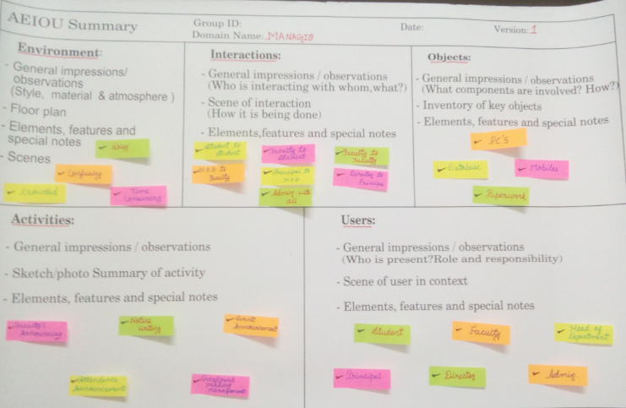

* **Activity:-**

While observation of the definitions we found some activities that can be reduced in order to save the time and energy. Following are the activities;-

Faculty Announcing: - We saw that the faculty needed to move from one class to another for announcing some announcement which can be sorted by an idea.

Notice writing :- In the institutes some of the common and important notices are to be hanged on the notice boards but the only problem was with the irregular student who many time misses such types of notices.

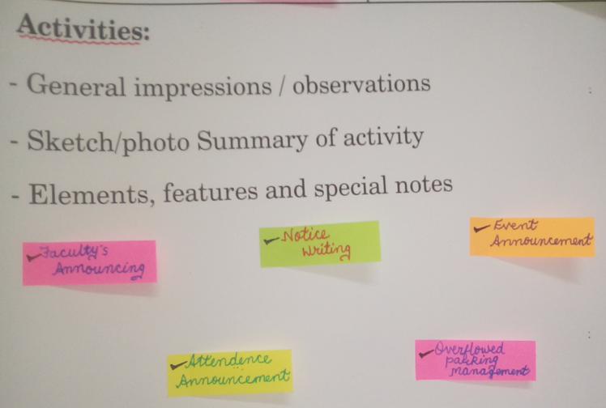

Event announcement: - Many Institutes just sometimes at the time of events keeps a notice about that on the board or else in that case some regular or interested students miss it up.

Attendance announcement :- Usually the attendance of the students of the institutes are displayed on the notice board which are sometimes teared or ignored by the students and in that case they keep on taking leaves and bunking the classes in a false assumption of the attendance been over the basic necessity.

* **User:-**

In an institution there are many who can make use of the application or the site so that the management becomes easy. Following can be the users of the application/portal:-

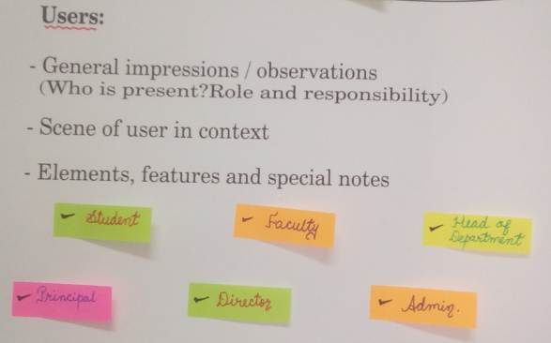

Student, Faculty, HOD, Principal, Director

* **Admin: -** Administration enters all the users as per the count of the students, staff and the director. They also maintain many features of the application. In case of any issue by the institution user he/she can contact to the admin.
* **Objects: -**

Pc: - Computer System that are used to operate the database and many other things such as attendance generation and declaration, events declarations, etc.

Database: - the entire paid or rental database to have the backup of the paper files and documents of the student’s details and resume of the faculty’s as well many things.

Mobiles: - All the mobile phones which are used by the students, faculties, principal, director and staff to communicate with each other and that also pay the cost.

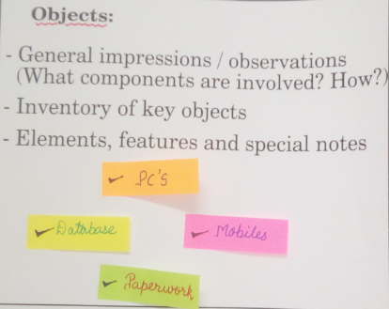

Paperwork: - All the Files and the Documents that are kept as the old and confidential data. And all the admission forms and all type of papers and assignments all come under the paper work.

* **Environment: -**

Noisy: - Due to those paper works and the lines for that all management the environment was observed very noisy which can be reduce till some extent with the help of this application implementation.

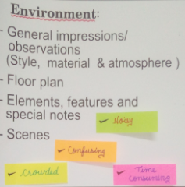

Crowded: - due to that long queue for the purpose the place of the institute was also observed crowded which can also be reduced till some extent.

Time consuming: - this entire paper works are obviously time consuming as there are many procedures of filling up the forms, getting the results after a huge search, etc.

* **Interactions: -**

At the time of the observation we got that who needs to have a communication with whom for the exchange of data the following are the ways of integration observed in the observation.

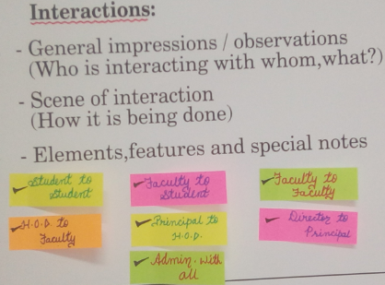

Student Student

Faculty Faculty

Student Faculty

Faculty HOD

HOD Principal

Principal Director

All Admin

* **Admin: -**

All the users can interact with admin and collect some information or they can edit their information from there.

**2.2 Empathy Mapping Canvas: -**

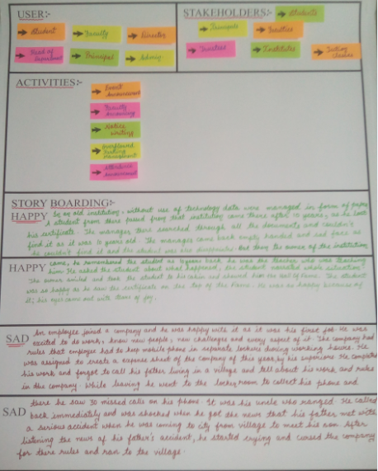

* **User: -**

In an institution there are many who can make use of the application or the site so that the management becomes easy. Following can be the users of the application/portal:-

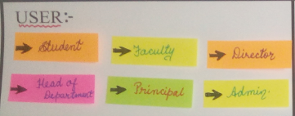

Student, Faculty, HOD, Principal, Director

Admin: - Administration enters all the users as per the count of the students, staff and the director. They also maintain many features of the application. In case of any issue by the institution user he/she can contact to the admin.

* **Activity**

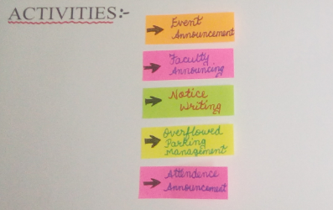

While observation of the definitions we found some activities that can be reduced in order to save the time and energy. Following are the activities;-

Faculty Announcing: - We saw that the faculty needed to move from one class to another for announcing some announcement which can be sorted by an idea.

Notice writing :- In the institutes some of the common and important notices are to be hanged on the notice boards but the only problem was with the irregular student who many time misses such types of notices.

Event announcement: - Many Institutes just sometimes at the time of events keeps a notice about that on the board or else in that case some regular or interested students miss it up.

Attendance announcement :- Usually the attendance of the students of the institutes are displayed on the notice board which are sometimes teared or ignored by the students and in that case they keep on taking leaves and bunking the classes in false assumption of the attendance been over the basic necessity.

* **Stake holders:-**

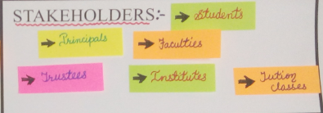

Student**: -** student is the most valuable stakeholders of the application and the institutions because if there is no student there will be any more institute or application

Faculties: - Faculties play the main role as they are the knowledge sharer because if there were no faculties who would have taught the students and gave the knowledge about the latest technologies.

Principles: - they are the one who are there to just supervise the faculties work over to the student and if any complaint of a faculty is registered then check through the matter and has a talk with particular faculty.

Trusties:-Are the one who owns the institute or the one who establishes the institute and it’s his decision to appoint the appropriate principal of the institute.

**2.3 Ideation Canvas**

* **People:-**

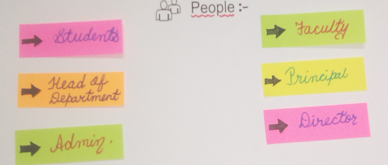

In an institution there are many who can make use of the application or the site so that the management becomes easy. Following can be the users of the application/portal:-

Student, Faculty, HOD, Principal, Director

Admin: - Administration enters all the users as per the count of the students, staff and the director. They also maintain many features of the application. In case of any issue by the institution user he/she can contact to the admin.

* **Objects:-**

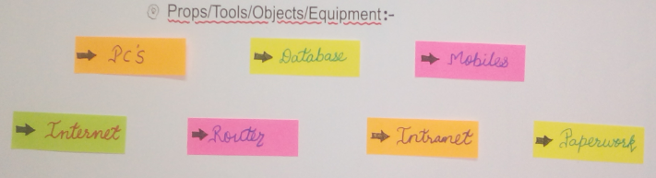

Pc: - Computer System that are used to operate the database and many other things such as attendance generation and declaration, events declarations, etc.

Database: - the entire paid or rental database to have the backup of the paper files and documents of the student’s details and resume of the faculty’s as well many things.

Mobiles: - All the mobile phones which are used by the students, faculties, principal, director and staff to communicate with each other and that also pay the cost.

Paperwork: - All the Files and the Documents that are kept as the old and confidential data. And all the admission forms and all type of papers and assignments all come under the paper work.

* **Activity:-**

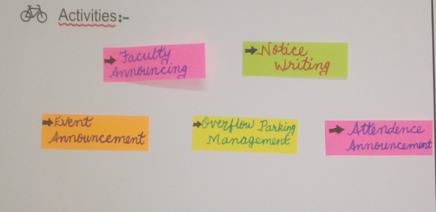

While observation of the definitions we found some activities that can be reduced in order to save the time and energy. Following are the activities;-

Faculty Announcing: - We saw that the faculty needed to move from one class to another for announcing some announcement which can be sorted by an idea.

Notice writing :- In the institutes some of the common and important notices are to be hanged on the notice boards but the only problem was with the irregular student who many time misses such types of notices.

Event announcement: - Many Institutes just sometimes at the time of events keeps a notice about that on the board or else in that case some regular or interested students miss it up.

Attendance announcement :- Usually the attendance of the students of the institutes are displayed on the notice board which are sometimes teared or ignored by the students and in that case they keep on taking leaves and bunking the classes in false assumption of the attendance been over the basic necessity.

* **Situation/Context/Location:-**

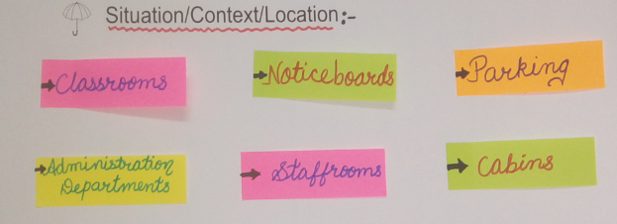

Classrooms: - This is the place where most of the time students are there so this is the location where usually the faculties have to come and announce the notice or assign the tasks to the students.

Notice boards: - Usually all the notice regarding the marks of the students, the attendance of the students and the events organised in the institute are announced on the notice board of the institutes.

Parking: - It’s the common place for all the members of the institute to park their vehicles so whenever the events are organised at that time the management of the parking and the announcement is being hard to declare.

Administration department: - At the time of the examination receipts collection and the mark sheet collection, etc. The department is full of students and the management becomes pretty tough.

Staffrooms: - Staffrooms are the place where the faculties can communicate with each other and prepare the lesson plans and the examination papers to gather for the examinations.

**2.4 Product Development Canvas**

* **Purpose:-**

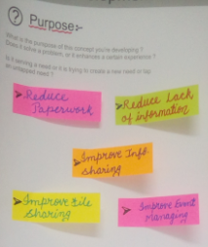

**Reduce paperwork: -** To keep the papers or the docs for long time is very tough so that to reduce that tension of managing the papers it can be made digitally.

**Reduce lack of information :-** sometimes some of the students are not been aware about the events and the completions that are occurring in the institutes and they at last have no choice than not participating.

**Improve information sharing: -** By updating the events and the notices of the institutes on the wall of the institutes so that all the students get aware about the events and completions.

**Improved file sharing: -** File sharing can also be done so that the students don’t have to move to the faculty and time can be consumed. File such as pdf’s, docs, excel, etc. can be shared including the images.

**Improved event managing: -** The Links of the events can also be shared so the students interested can move to the events there. The events organized in the institute can also be declared on the portal/application.

* **People:-**

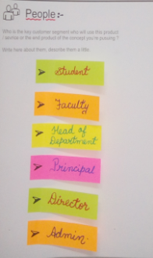

In an institution there are many who can make use of the application or the site so that the management becomes easy. Following can be the users of the application/portal:-

Student, Faculty, HOD, Principal, Director

Admin: - Administration enters all the users as per the count of the students, staff and the director. They also maintain many features of the application. In case of any issue by the institution user he/she can contact to the admin.

* **Product Experience:-**

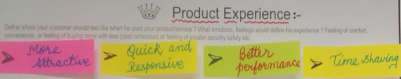

Quick and responsive:-Responses on the application as well as the site are pretty quick as there would be no advertisements issues as well as the Api’s used will be most efficient.

More attractive: - The application can be more attractive because of the features that are going to be implemented and the simplicity of the application.

Better performance: - As the Hardware as well as the software specification is not going to be high the performance of the application gets improved.

Time saving: - Of course as the paper work goes on reducing it gives you chance of shaving the time for other works.

* **Components:-**

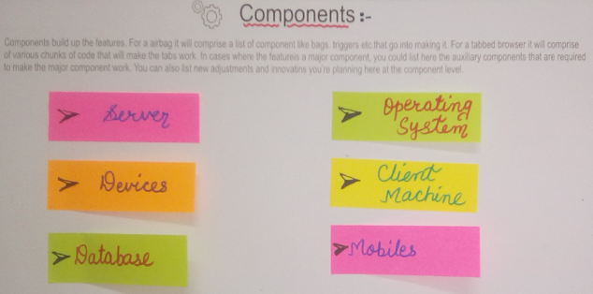

1. Server:- It is the most important component for the completion of the project because without server the data from the database cannot be exchanged.
2. Operating System:- Its is also important to have a OS in the PC or the mobile or else the site cannot be opened nor the application can be installed.
3. Client Machine: - Client machine can be anything such as the computers, the laptops, the tablets, the mobiles everything with the help of which the user can operate the application or the portal.
4. Database: - It’s the place where the data about the particular institute is placed as well as all the data of every student are saved and the exchange of the data can be done only with the help of the database.

* **Customer Revalidation:-**

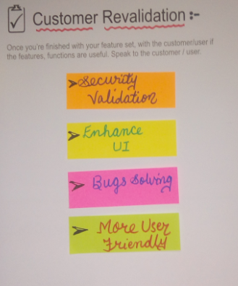

Customer Revalidation means to give a trial to the client and then fetching the reviews and the changes that can be made ahead in this application/portal. The following things can be added to the application later on:-

1. Security validations
2. Enhance UI
3. Solving Bugs
4. Make it more user friendly

* **Reject, Redesign and Retain:-**

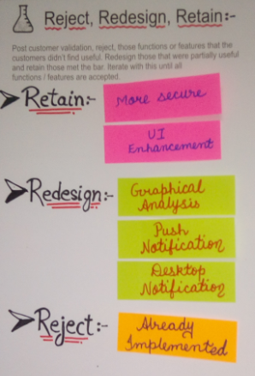

**Retain:-** Where there are some minor changes that can be done easily in the application/portal then the project can be retain(continued).

**Redesign:-** Where the condition comes that the whole application is needed to change and place the correct things on the correct place then this phase is said to be the redesign phase.

**Reject:-** the condition where nothing else can be done you need to stop the work and the project cannot processed at that time you need t reject the idea.

1. **User Feedback And Rough Prototype**

**3.1 Version 1.0 Prototype:-**

The below given Screenshots gives the perfect Summary about the Project which can be said as prototype.

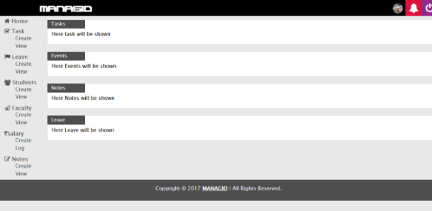

From the above screenshot we can have Task management, Leave Management, Students Management, Faculty Management, Salary Management, Notes Management and many more facilities that can be implemented for the users to make their life and communication easy and clear.

For Task management faculties/managers can create a new task for student/employee and also can display or notify them personally. For Student management admin/teachers can notify students with their notes, attendance, fees, college functions, announcements, and many more things. Salary Management gives functionality for admin to notify faculties and all staff with their salaries and leaves, etc.

**4. Prior Art Search**

**]**

**4.1 Research Paper Summary**

1. **Student Management System Using RFID**

**By Unnati A. Patel Volume 2, Issue 6, November – December 2013 ISSN 2278-6856**

Educational institutions’ administrators are concerned about student irregular attendance. Checking students' attendance is one of the important issues for universities, because many universities evaluate students’ attendance while giving the final grade, professors consider their total number of appearances on classes during the whole semester. This brings to the idea of having some tool to control students’ attendance. However, Current manual way of taking student attendance is not an efficient way since there will be spent much of time for calling students names and putting marks like "presence" or "absence" if the class Is a lecture class, and in this class at least 5 groups are presented. Moreover, some students may call his/her friend as "presence" even though this student is currently absent. After thinking all these issues, author of the following research paper decided to create a system that makes easier to check students’ attendance automatically. The system is based on RFID technology, and in this paper, details of this system are presented. The system can be easily accessed by the lecturers via the web and most importantly, the reports can be Generated in real-time processing, thus, providing valuable information about the students’.**2. Web Based Student Information Management System**

**By S.R.Bharamagoudar, Geeta R.B., S.G.Totad International Journal of Advanced Research in Computer and Communication Engineering Vol. 2, Issue 6, June 2013**

Student Information Management System (SIMS) provides a simple interface for maintenance of student information. It can be used by educational institutes or colleges to maintain the records of students easily. The creation and management of accurate, up-to-date information regarding a students’ academic career is critically important in the university as well as colleges. Student information system deals with all kind of student details, academic related reports, college details, course details, curriculum, batch details, placement details and other resource related details too. It tracks all the details of a student from the day one to the end of the course which can be used for all reporting purpose, tracking of attendance, progress in the course, completed semesters, years, coming semester year curriculum details, exam details, project or any other assignment details, final exam result and all these will be available through a secure, online interface embedded in the college’s website. It will also have faculty details, batch execution details, students’ details in all aspects, the various academic notifications to the staff and students updated by the college administration. It also facilitate us explore all the activities happening in the college, Different reports and Queries can be generated based on vast options related to students, batch, course, faculty, exams, semesters, certification and even for the entire college.

**3. College Management System**

**By Lalit Mohan Joshi International Journal of Computer Applications (0975 – 8887) Volume 122 – No.11, July 2015**

This paper is aimed at developing an Online Intranet College Management System (CMS) that is of importance to either an educational institution or a college. The system (CMS) is an Intranet based application that can be accessed throughout the institution or a specified department. This system may be used for monitoring attendance for the college. Students as well as staffs logging in may also access or can be search any of the information regarding college. Attendance of the staff and students as well as marks of the students will be updated by staff. This system (C.M.S) is being developed for an engineering college to maintain and facilitate easy access to information. For this the users must be registered with the system after which they can access as well as modify data as per the permissions given to them. CMS is an intranet based application that aims at providing information to all the levels of management with in an organization. This system can be used as a knowledge/information management system for the college. For a given student/staff (technical/Non-technical) can access the system to either upload or download some information from the database.

1. **Android College Management System**

**By Vishwakarma R Ganesh International Journal of Advanced Research in Computer Engineering & Technology (IJARCET) Volume 5, Issue 4, April 2016**

Android College Management system is an android application which is helpful for students as well as the colleges. In the existing system all the activities are done manually. It is very costly and time consuming. In our proposed system, students can view results using Android phones. The data will be stored in the college server. The faculty can login into their college account through the app itself and update the academic result. In this system, students have easy access for viewing the marks, provided their authentications are correct and they are not permitted to change/update the marks. The proposed work has two modules:

1. Student

2. Admin.

In the student’s module, student need to register their roll no, college registration number, student name. Admin module maintains the student’s marks of internal college exams. Other than this the advanced features are: In case of natural calamities such as floods, etc. notification to students will be sent from admin office through app directly. Any new notice for a particular semester will be uploaded by professor through application notifying to respective semester students. Application also includes logic to support above mentioned facilities to its students, however if the person downloading the application is not a student but an aspirant who has completed HSC and wants to know about the college then it only includes the advertisement of the college. Senior college toppers can also share their tips and tricks with other students via chat interface. Student’s attendance is also monitored by the application.

1. **STUDENT INFORMATION AND SCORE MANAGEMENT SYSTEM**

**By Prof. D. M. Dalgade, Aishwarya Pandey, Garima Negi, Neeti Popat ISSN (PRINT): 2454-406X, (ONLINE): 2454-4078, VOLUME-2, ISSUE-2, 2016**

The management of student related information in an educational institute gets more tedious with every passing year as all systems in today’s world are being computerized; there is a need for an automated system for managing such information. Student Information and Score Management System (SISMS) provides a simple interface for maintenance of student information. It can be used by educational institutions or colleges to maintain the records of students easily. The creation and management of veracious, state of the art information regarding a students’ academic career is critically important in the university as well as colleges. Student information and score management system deals with all kind of student information, academic reports, college details, course details, curriculum, batch details, score management and other resource related details too.

**5. Final Product**

**Login Page**

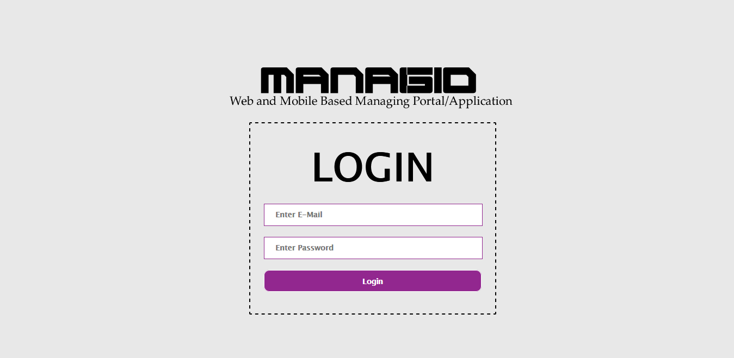

**Dashboard**

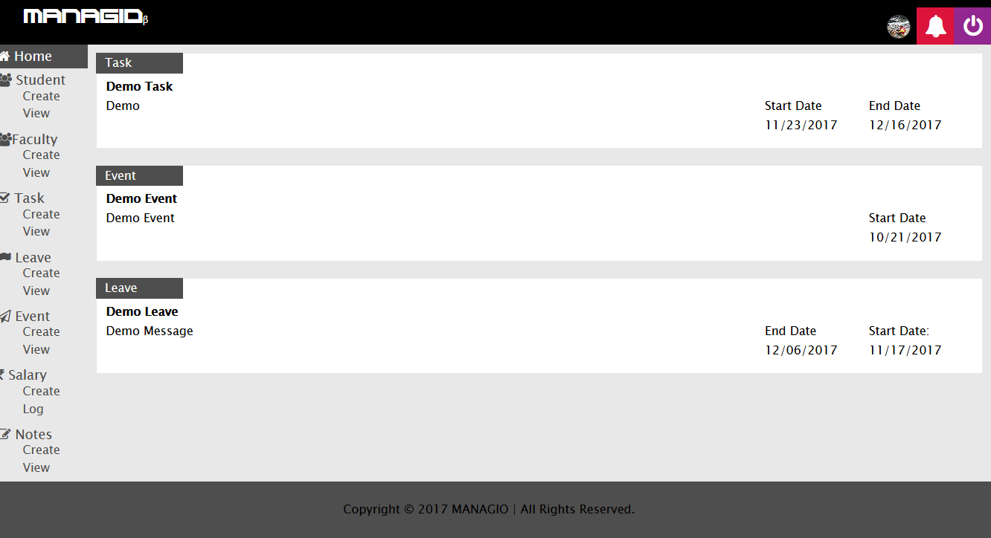

**Create Student**

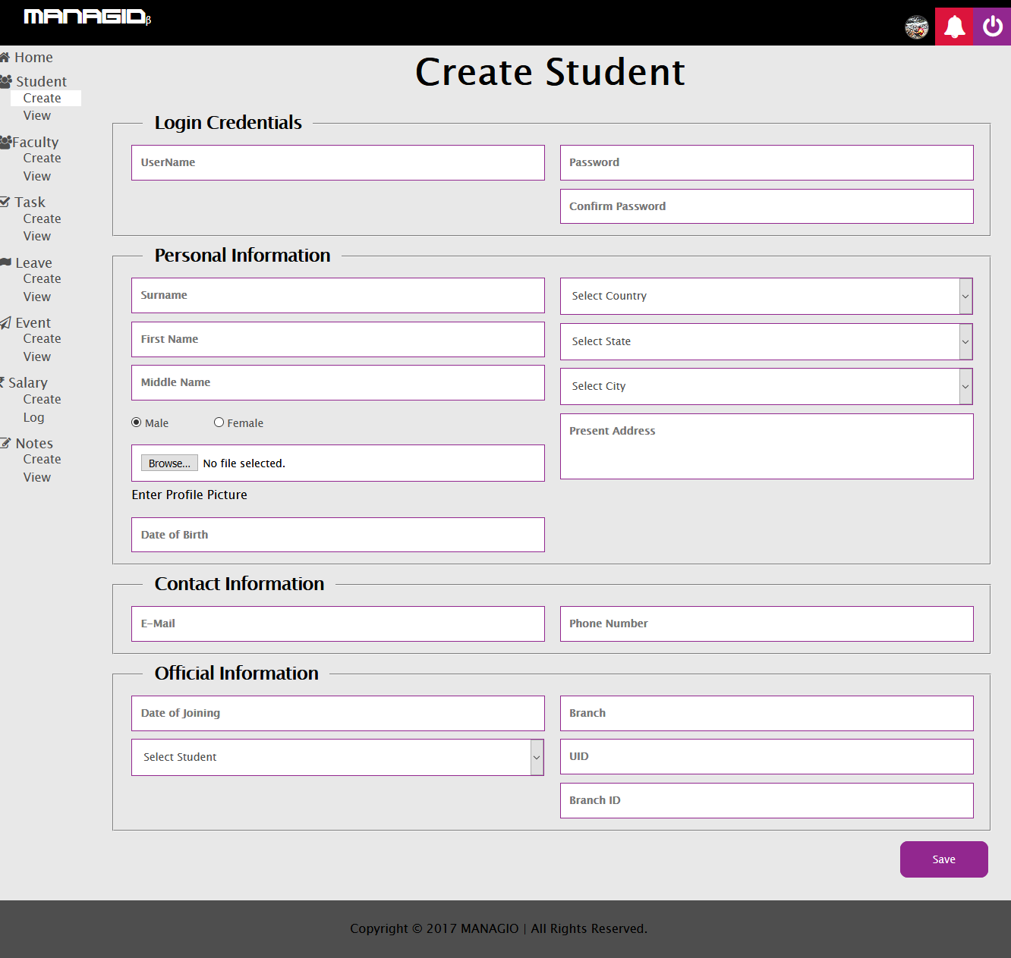

**View Students**

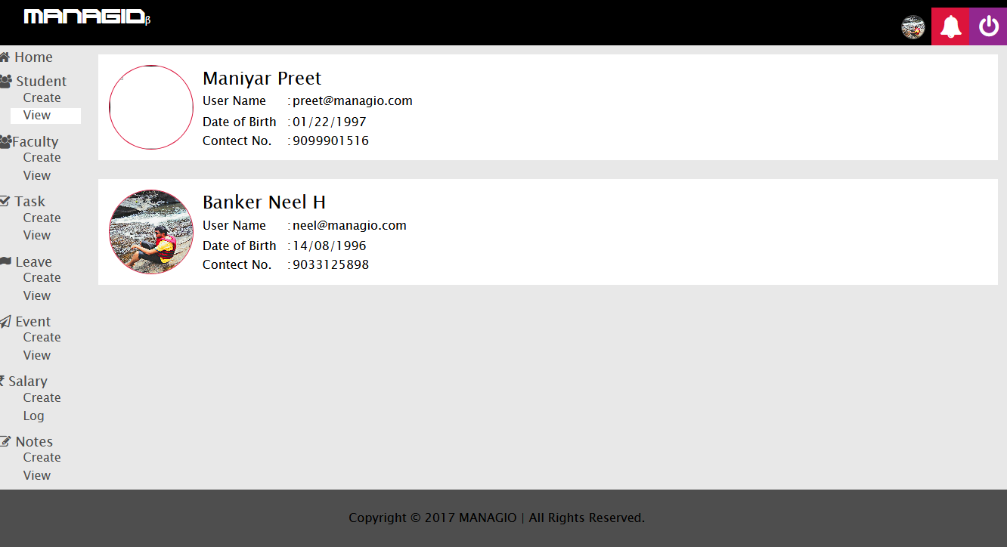

**Student Details**

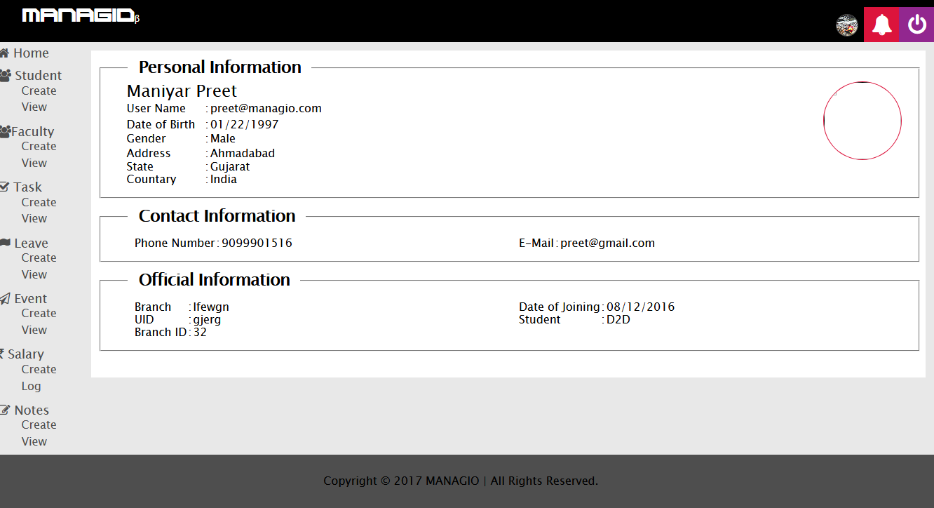

**Create Employee**

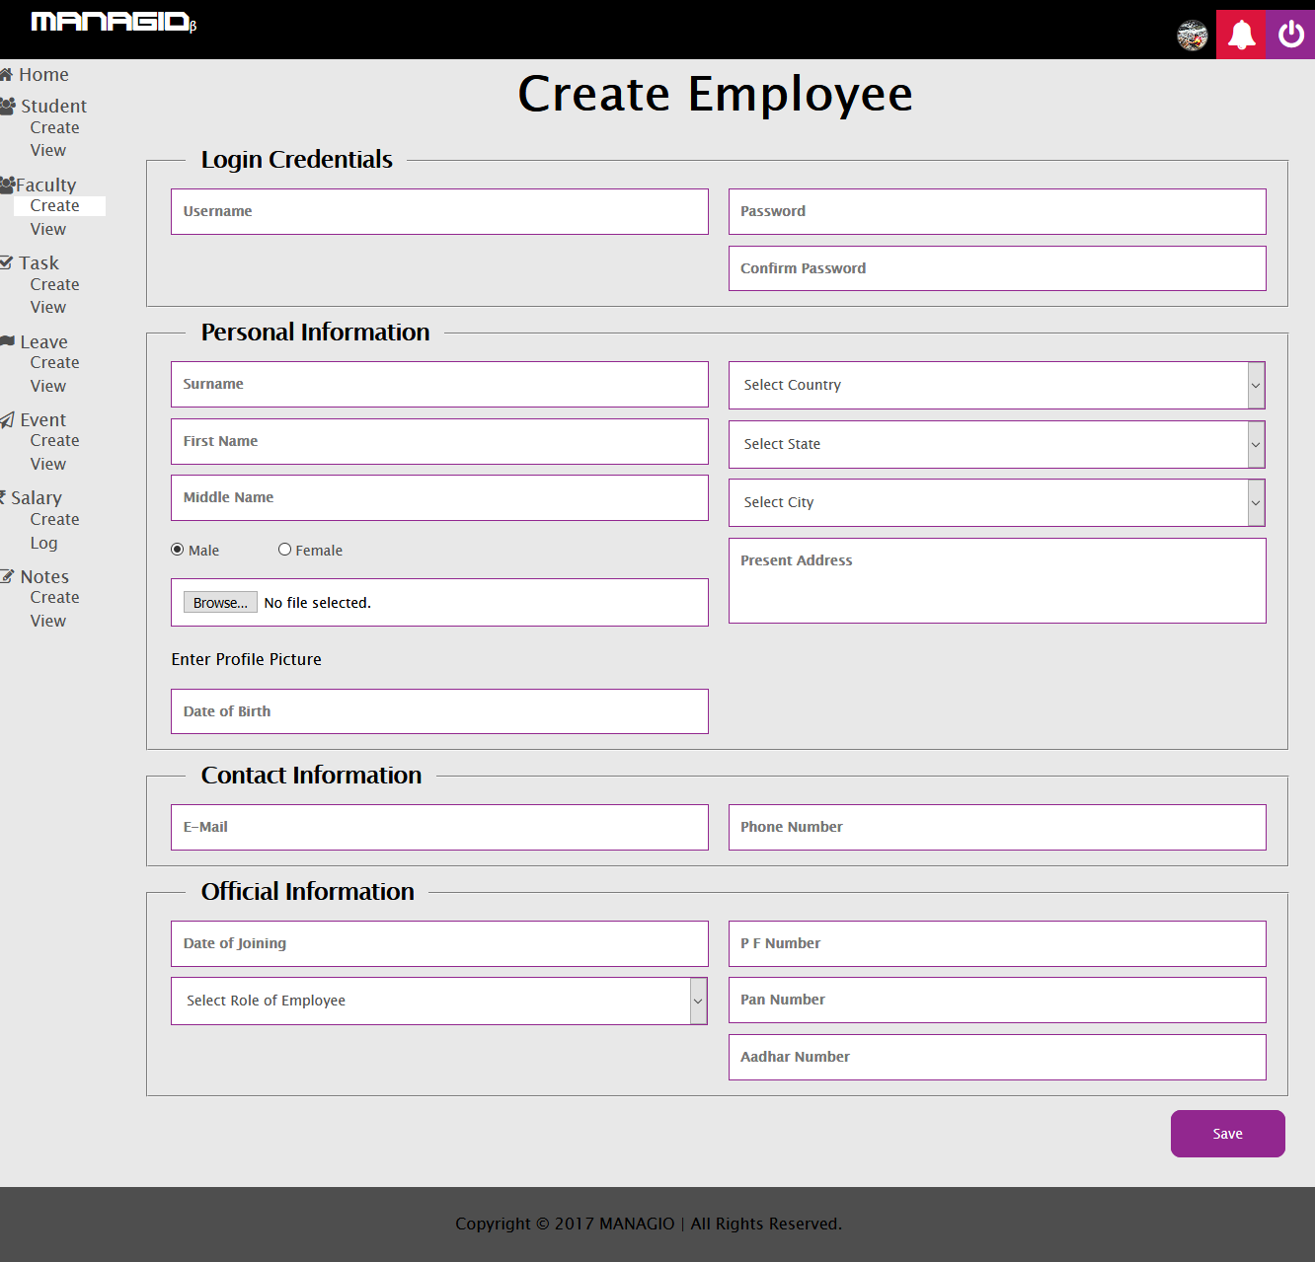

**Employee Details**

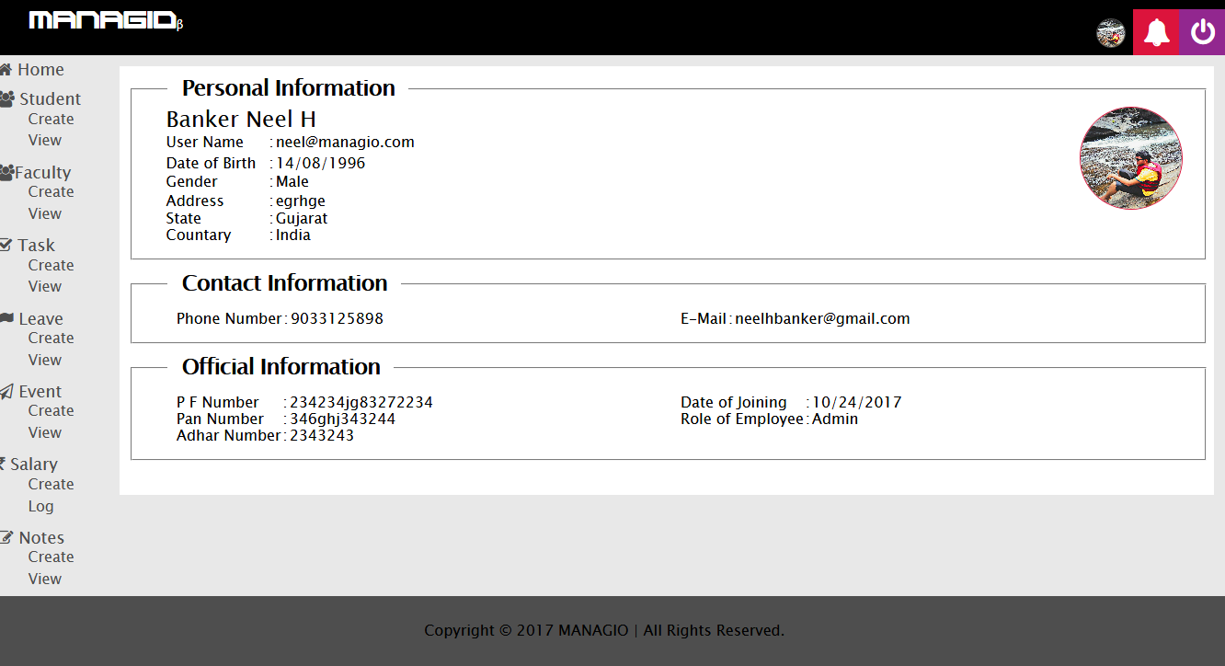

**Create Task**

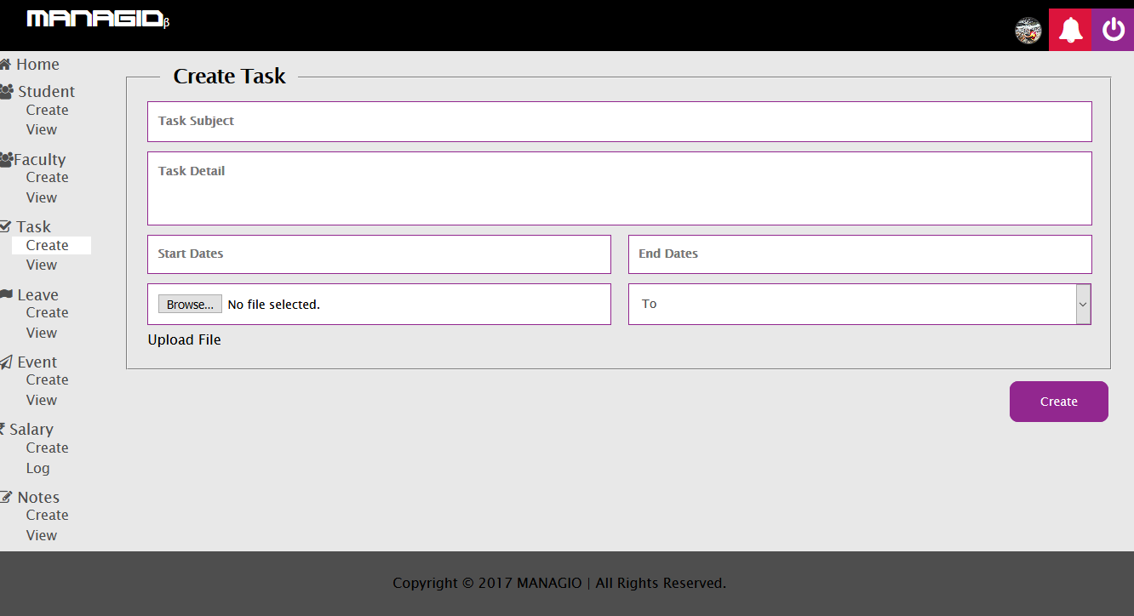

**View Tasks**

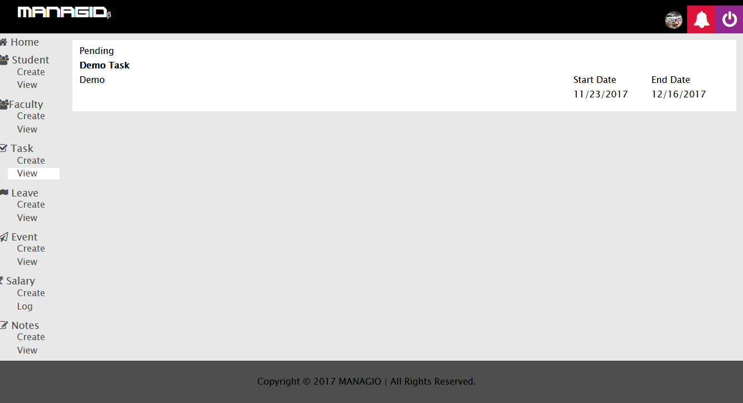

**6. Conclusion**

This application & web portal idea gave us many more things to learn and to make more powerful in many skills then we expected. We think that in future as we reach towards the ending of the project we will get much more things to learn on the present technology such as the online database connectivity and multi-devices simultaneous database connection, as well as the UI enhancement is also a huge concept to have a look and learn on. These are some of the future expectation but the present one which we got some learned are the observation skills on the activities going on in the surrounding environments and the objects that are been the medium of the interaction between both of them. All these gave us little but very important knowledge of observation...

**7. References**

1. [**http://gtuinnovationcouncil.ac.in/blog/category/design-engineering/**](http://gtuinnovationcouncil.ac.in/blog/category/design-engineering/)
2. [**https://imindmap.com/how-to-mind-map/**](https://imindmap.com/how-to-mind-map/)
3. [**http://www.ijarcce.com/upload/2013/june/4shobha%20bharamaoudar-WEB%20BASED%20STUDENT%20INFORMATION**](http://www.ijarcce.com/upload/2013/june/4shobha%20bharamaoudar-WEB%20BASED%20STUDENT%20INFORMATION)
4. [**www.ijettcs.org/Volume2Issue6/IJETTCS-2013-12-11-064**](http://www.ijettcs.org/Volume2Issue6/IJETTCS-2013-12-11-064)
5. [**https://thejournal.com/Articles/2005/10/01/The-Evolution-of-Student-Information-Systems.aspx**](https://thejournal.com/Articles/2005/10/01/The-Evolution-of-Student-Information-Systems.aspx)
6. [**https://en.wikipedia.org/wiki/Student_information_system**](https://en.wikipedia.org/wiki/Student_information_system)**=**
7. **https://www.researchgate.net/figure/221786973_fig1_Figure-10-Synchronic-analysis-an-example-of-behavioural-analysis-and-MEAS-scoring**